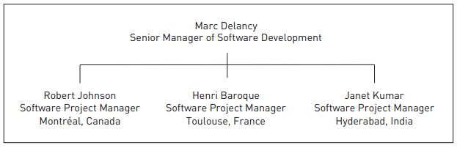

|  |  |  |  |
| --- | --- | --- | --- |
| NAME | Title | Description | Responsibility |
| Marc Delancy | Senior Manager of Software Development. | Marc is an experienced manager who has led multiple teams in the development and delivery of software products on time and within budget. Marc has led virtual teams but is new to global software development. He faces challenges that he did not have when man-aging teams located at one site or within the same geographical area.  He thinks that he has recently been troubleshooting problems rather than managing decisions to minimize problems in the project execution. | Marc Delancy is responsible for delivering a new product to manage transmissions over ﬁber-optic networks |
| Robert Johnson | Software Project Manager, **Montréal, Canada.** |  | Robert Johnson is responsible for the QoS algorithms |
| Henri Baroque | Software Project Manager, **Toulouse, France** |  | Henri Baroque team is responsible for develop User interface layer |
| Janet Kumar | Software Project Manager, **Hyderabad, India** |  | Henri Baroque team is responsible for develop Business layer |